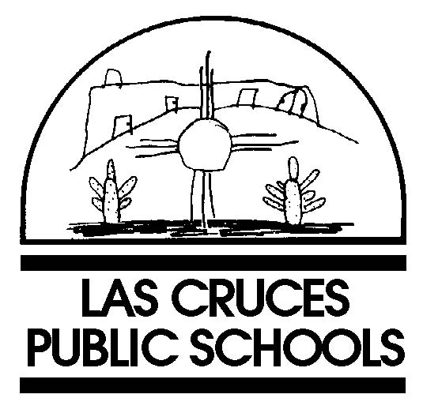  BOARD OF EDUCATION  Chuck Davis  Maria A. Flores  Connie Phillips, Ph.D.  Serena Shoop  Bonnie Votaw, Ed.D.  Stan Rounds  Superintendent    OUR MISSION  The Las Cruces Public  Schools is committed  to providing a  high-quality, world-class  education that ensures  success for every student  through excellence in  teaching resulting in higher  academic achievement.  505 S. Main St., Suite 249 Las Cruces, NM 88001 575.527.5811 www.lcps.k12.nm.us |  | April 29, 2010  Mr. Salvatore Saporito  Department of Sociology  The College of William and Mary  Williamsburg, VA 23187  Sent via e-mail: sjsaop@wm.edu  Re: Inspection of Public Records Request April 28, 2010  Dear Mr. Saporito:  On March 28, 2010, I received your request, via e-mail, for documents from the Las Cruces Public Schools. Under the provisions of New Mexico’s Inspection of Public Records Act (“IPRA”), N.M. Stat. Ann. § 14-2-1 et. seq. (2005), you will be provided the documents that exist.  As you mentioned in your e-mail, you requested the current boundaries for the 2009/2010 school year. If you are actually requesting the adjusted boundaries which were just recently approved by the Las Cruces Board of Education (effective for the 2010/2011 school year), please let me know right away. The new boundaries also were developed with the assistance of Architectural Research Consultants.  Please note there will be a $.50 per page fee as allowed under N.M. Stat. Ann.  § 14-2-8(D) (2005) for the documents requested, regardless of digital format.  Available records will be sent to you by May 13, 2010.  Sincerely,  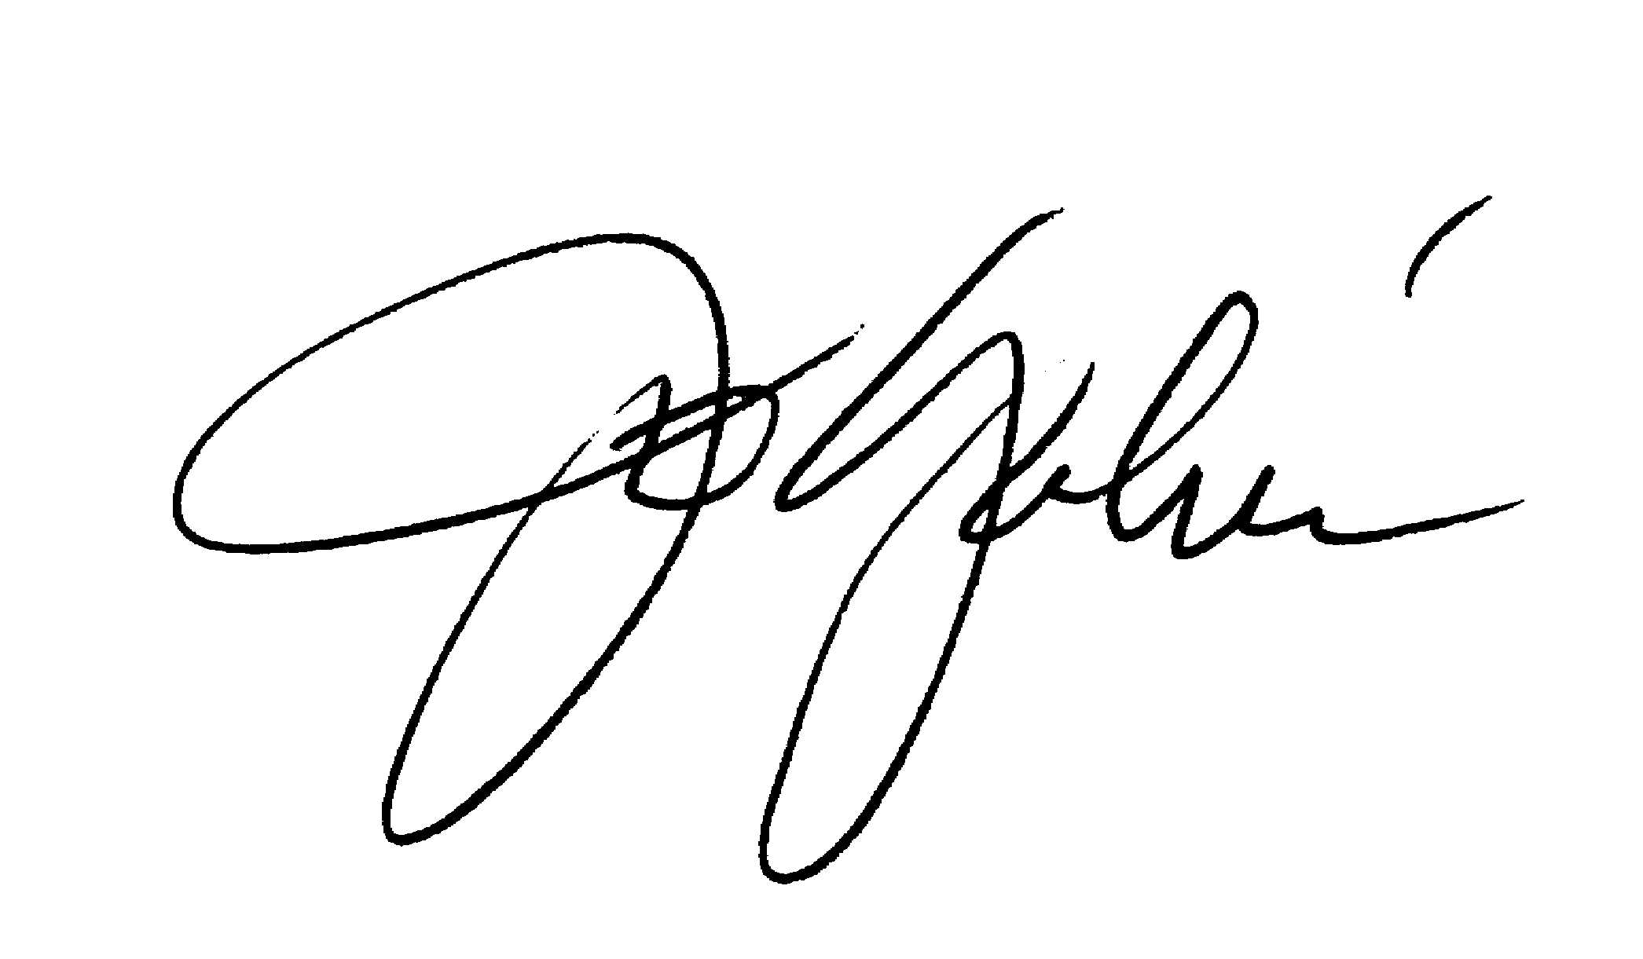  Jo Galván  Director of Communications & Community Relations  c: Stan Rounds

