[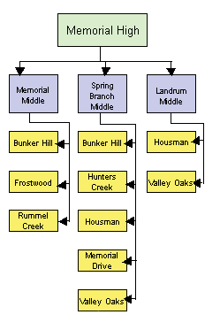](http://www.springbranchisd.com/schools/schools.htm)

[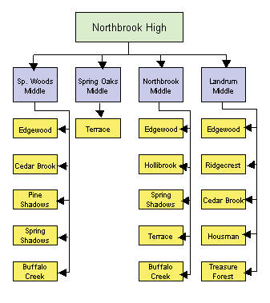](http://www.springbranchisd.com/schools/schools.htm)

[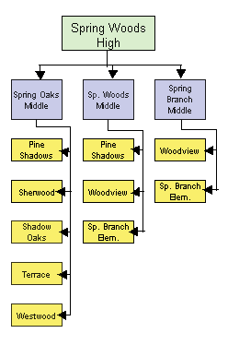](http://www.springbranchisd.com/schools/schools.htm)

[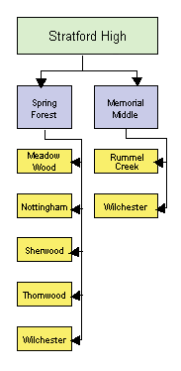](http://www.springbranchisd.com/schools/schools.htm)